Q1: Create a folder and insert three files.

Sol

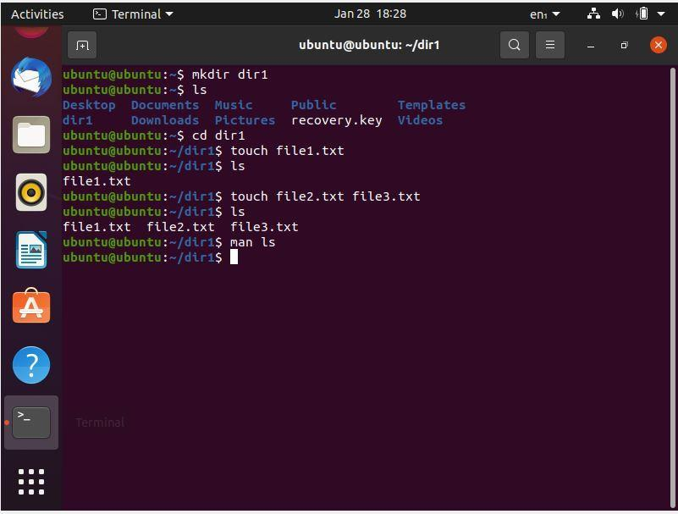

Q2 ls: command list out all the files which you added(use man command use 3 or 4 commands)

Q3: mkdir==>to create new directory

Q5 touch==>to create an empty file

Q6:  rmdir-->to remove directory

Q7: rm=> to remove a file

Ans

Q8: cal==> current month calendar

Q9: date==>to display current date and time.

Q10: help--> to display list of commands

